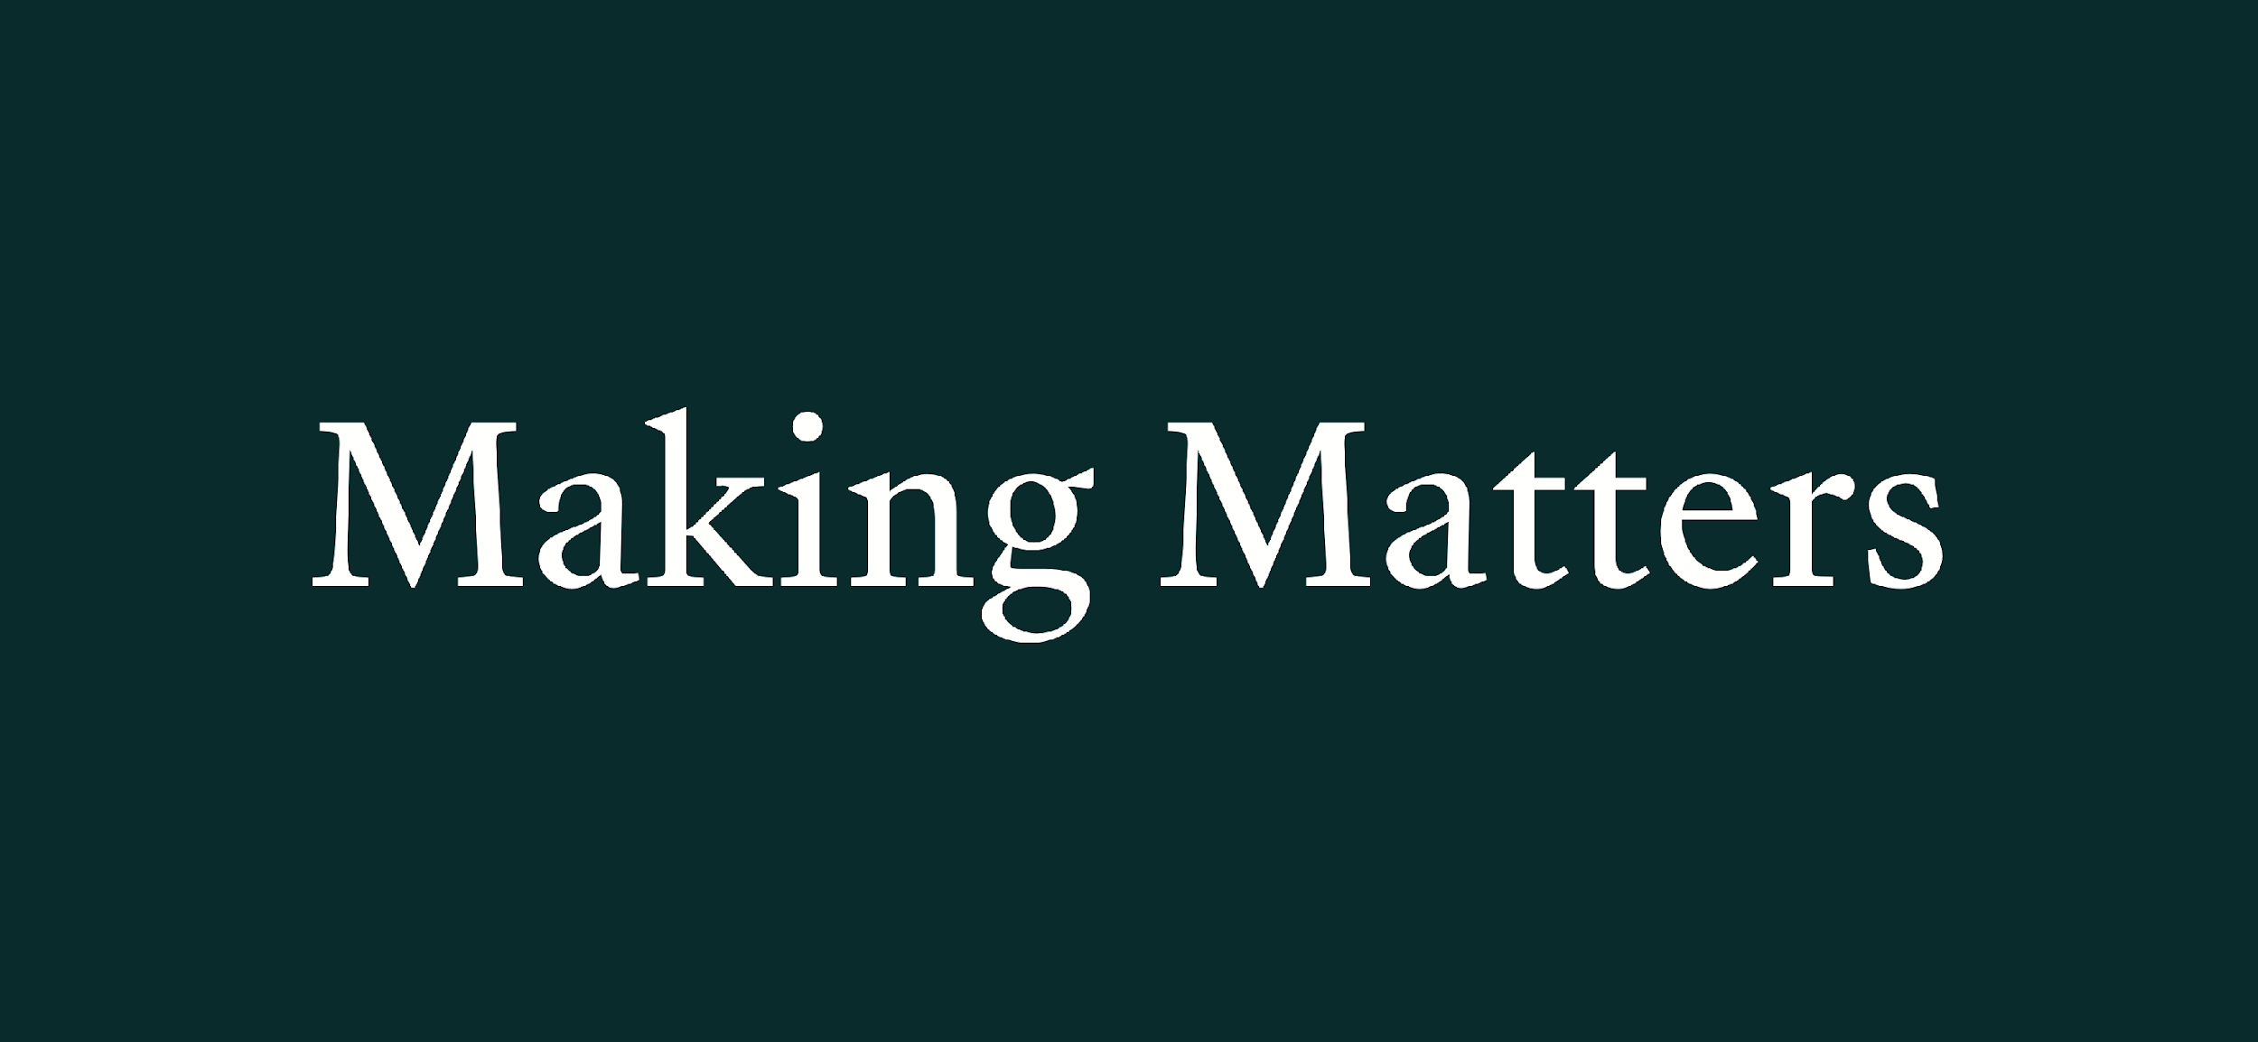
Pop-Up 2024
Open Call
Deadline: 2.5.24

Welcome to Making Matters and the Pop-Up shop. Making Matters is an artists’ group with its roots in Farnham. We set up in 2020. We run 2 art and craft pop-up shops a year, October and Christmas as well as running Community Art Projects, such as the Brick Project. This is our 5th consecutive year of running a pop-up in Lion and Lamb Yard, Farnham.
Criteria for applying:
We look at artists’ Instagram and websites to see what work will go well in the shop and have the following criteria for participating artists:

- have a connection with Farnham
- should be making original work of high standard
- experience in exhibiting/displaying own work
- be actively promoting on social media (Instagram and/or website)
- be technically savvy (eg Zettle)
- work well as part of a team
- available for set up & take down dates
- local is helpful
NB we are unable to sell precious metal jewellery
Important dates:

 | October*(Craft Month) |  | Christmas
Q & A zoom | 16.9.24 at 7pm |  | 28.10.24 at 7pm
Set Up | 28.9.24 or 29.9.24 (9.30 - 5pm) |  | 11.11.24 or 12.11.24 (9.30 - 5pm)
Residency period | 1.10.24 - 9.11.24 |  | 13.11.24- 23.12.24
Open: | Wed to Sat 10 - 5pm Sun 12 - 3pm  Closed: Mondays & Tuesday |  | Nov:  Wed to Sat 10 - 5pm Sun 12 - 3pm  Dec:  Mon to Sat 10 - 5pm; Sun 12 - 3pm
Launch & Private View | 1.10.24 Launch (12-1);  PV (5.30- 8pm) |  | 14.11.24 PV (5.30-8pm)
Take Down: | 9.11.24 (4-6pm) or  10.11.24 (9am -12 noon) |  | 23.12.24 (4-7pm) or 27.12.24 (9am - 12 noon)

*October Craft Month is a celebration of crafts with a programme of events taking place across the town and surrounding area. It’s a great opportunity to showcase your work and benefit from the wider publicity around Farnham World Craft Town events.
Taking part:
The pop up is a collective enterprise and we ask all artists involved to contribute to the running and promotion of the shop. Sharing of stewarding responsibilities, including keeping the shop clean and tidy, is a key part of this and all applicants are expected to be able to undertake 6 full days stewarding (TBC) during their time at the pop up. NB This may go down, depending on the number of participants & shop layout. Shifts:
- 9.30-1.30
- 11 - 3
- 1.15-5.15
NB Only shifts 1 & 3 can be used to make a full day.

We know that not everyone is close to Farnham so your sessions can be made up of full or half days.
Please consider carefully whether you are able to commit to this before applying.

Promotion :
The pop up has always been well supported by Farnham town council with good coverage from local news. Since we started 5 years ago, with our first pop-up shop, the Mayor of Farnham has formally launched our shops, as part of Farnham Craft Month. We are hoping to be able to arrange this again for this year. We will also have a Private View for both pop-up shops as well as actively promoting the shop through our own social media platforms. We ask all artists taking part to play an active part in promotion through their own social media platforms as well.

Selection :
We will announce successful artists on 28.5.24. In the event that responses exceed our capacity we will create a waiting list of interested artists who will be contacted if spaces become available.

Fees
£200 - payable on signing of contract by 10.06.24. This is non-refundable (unless, in the unlikely event, we do not get a shop. In this case, we will give a full refund). A 20% commission will be payable on all sales (this includes 1.75% commission payment for Zettle transactions).

We hope that’s given you an idea of what we’re all about. If you meet the criteria, and are happy with the conditions and dates, download your application form here.

All the best,
Making Matters Pop-Up Team

popupmakingmatters@gmail.com
www.Making-Matters.co.uk
Instagram: @Making_Matters

